###### AGARAM POWER SOLUTION

About us

**Agaram Power Solution are one of the well-known suppliers and dealers of a quality-assured range of solar panel, solar power plant, street light, water heater, pump inverter, LED light and all solar energy products. These products are designed by considering the requirements of customers so that their specific needs get fulfilled. The entire range of products is manufactured in compliance with the international quality standards, using high-grade raw material. Moreover, the entire range of products is highly demanded in the market high efficiency, low maintenance, easy installation, durable standards and automatic on/off operations.**

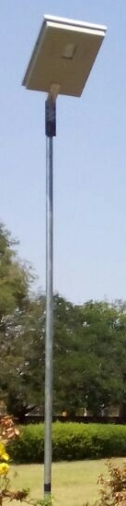**Solar Street light**

**Do you use street lighting all night? With the power of sunlight, light will be available without electricity throughout the night.This light works on dusk to dawn model.When the sun rays touches the panel, the lamp turns off automatically. This lamp can be used in the garden, farm houses, streets, houses and farms. It can be set up to 20 feet in height.**

#### Smart Solar Street Light

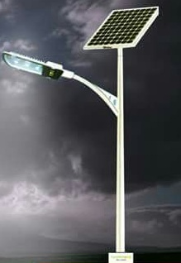It has no manual ON-OFF required (Fully automatic), No maintenance required (Lithium-ion battery), Long Life of product, Long battery Life 3 to 4 years, Easy installation, Long installation distance between two light (up to 15Mrt),Motion sensor - uses energy as required, Up to two days autonomy. This street has No discrete arrangement is to made for panel, battery, battery box, Luminary & Pole. Mode of Transport is easy, convenient and safe, No maintenance is required for battery (No water Top Up), No risk of battery theft, No designer pole required

##### Solar Street light integrated model

**The Integrated Street Light has Lamp- Japan Nichia SMD LED, Lithium po4 battery. The Life span of LED is long. Its Battery life span has high durability. It will be whole night Lighting, Suggested Installation Height – 5 meters. This solar street light is easy to install,no hanging wires or construction required.The lamp can light up an area 360o around the pole.It is maintenance free and eco friendly.it is widely used in street and roads,residential areas,scenic spots,parks,squares,private garden and other public places.**

**Fancy Solar Street Light**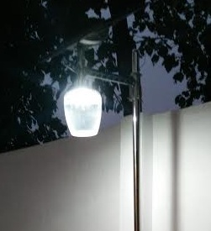

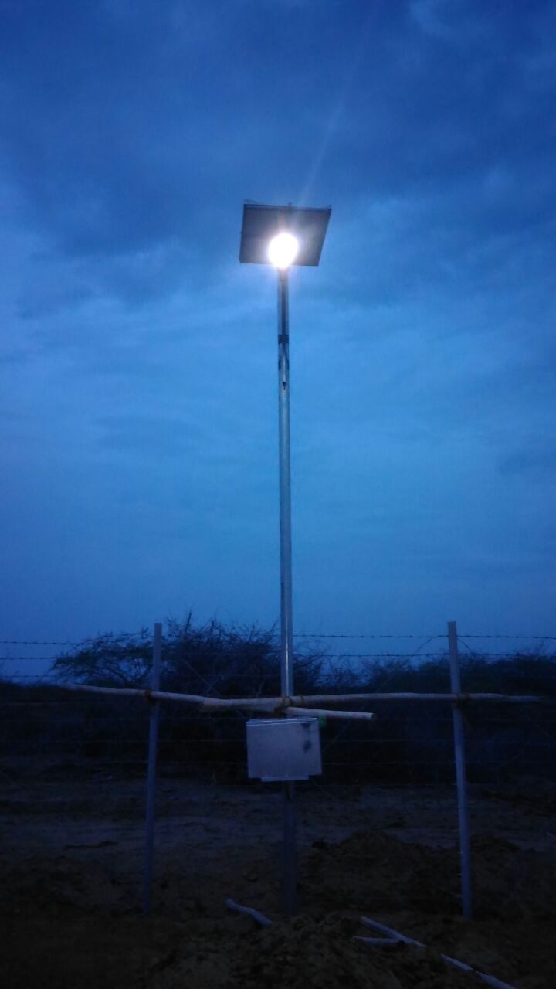 **The Integrated Street Light has Lamp- Japan Nichia SMD LED, Lithium po4 battery. The Life span of LED is long. Its Battery life span has high durability. It will be whole night Lighting, Suggested Installation Height – 3 meters. This solar street light is easy to install and it can be installed on pole or wall mounting,no hanging wires or construction required.It is less Investment.The lamp can light up an area 360o around the pole.It is maintenance free and eco friendly.it is widely used in street and roads,residential areas,scenic spots,parks ,private garden and other public places.**

### Solar Street Light

### Solar Street light is a stand-alone solar system consisting of pole, battery bank, solar panel and LED light based on customer requirement it can be customizes to wattage and brightness required and it can be designed for dusk to dawn operations with the required number of days. One of the way to light up your home or industrial premise, streets, highways, yards, compounds, parks, boundary walls, car parking areas be environmentally friendly and also keep recurring monthly bills to pay is to leverage the tremendous yet untapped benefit of solar powered LED lights.

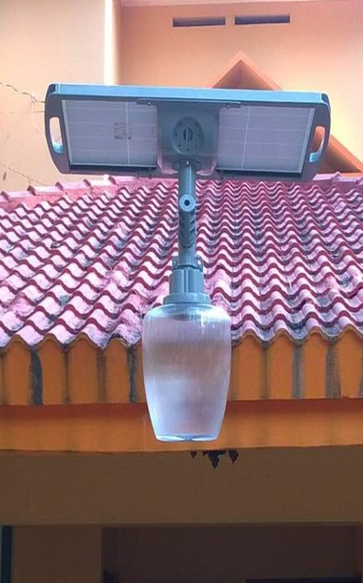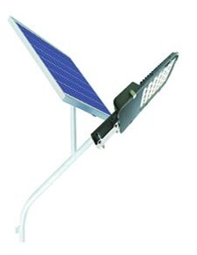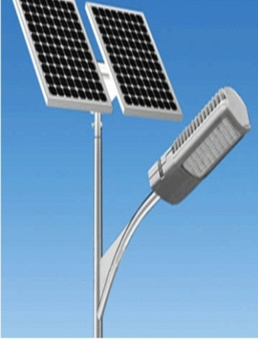

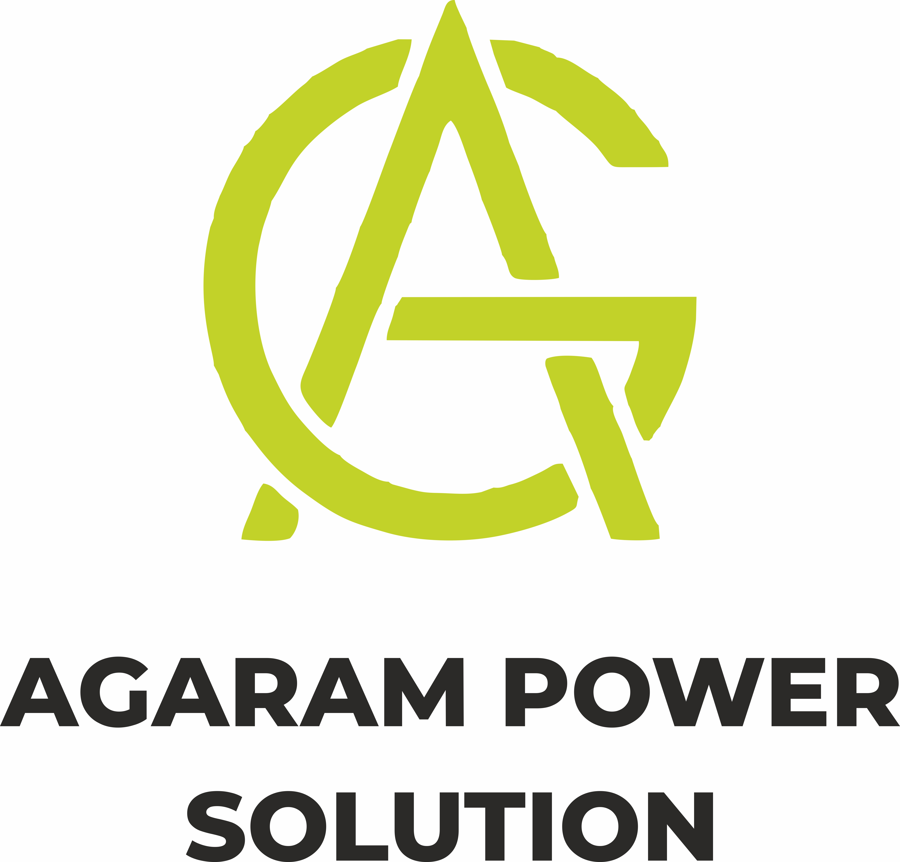AGARAM POWER SOLUTION

**37, M K Puram Main Road, Madurai-625011.**

**79, 11/1 A LAXMI VENKATESHWARA NILAYA**

**2ND CROSS BYRAWESHWARA NAGAR NEAR SUNKADAKATTE BUS STOP**

**Mobile :78670 15510, 73737348155** Email:agarampowersolution@gmail.com

Visit us on: [www.agarampowersolution.com](http://www.agarampowersolution.com)